**PITCHITUP: A PLATFORM AS-A-SERVICE FOR STARTUP PITCH DECK**

A Proposal

Presented to the Faculty of the

College of Computer Studies, University of Cebu

In partial Fulfillment of the Requirements

for the degree Bachelor of Science in Information Technology

By

Cantiveros, Angelica Joy G.

Golisao, Sherleen A.

Ochea, Shamie Lynn P.

Mr. Leo Bermudez

Adviser

March 2016

# APPROVAL SHEET

This Research/Capstone Project Study titled **PitchITup: A Platform-As-A-Service for Startup Pitch Deck** prepared and submitted by Angelica Joy Cantiveros, Shamie Lyn Ochea, Sherleen Golisao has been examined and is recommended for approval and acceptance.

RECOMMENDED:

**Mr. Leo Bermudez Mr. Bell Campanilla**

Adviser IT Research Coordinator

________________________________________________________________________

APPROVED by the Examining Tribunal on ***Oral Defense*** with a group verdict of **_________________**on **_______________**.

**Dr. Jonathan EtcubanPh.D**

Chairman

**Mr. HeubertFerolino Ms. EmelieVillaceran Engr. Jeff Salimbangon**

Member Member Censor

____________________________________________________________________

ACCEPTED and APPROVED in partial fulfillment to the requirements in Bachelor of Science in Information Technology.

**Melvin M. Niñal, PhD.**

Dean, UC-CCS

Date: .

# ACKNOWLEDGEMENT

This study would not have been possible without the guidance and the help of several individuals who in one way or another contributed and extended their valuable assistance in the preparation and completion of this study.

We would like to thank our Almighty God for bestowing us the courage, the strength, the guidance as well as the perseverance to strive hard in realizing this work. We offer all to Him, in the glory of His name, for He knows everything more than anybody else.

To Dr. Melvin M. Niñal for his time in enlightening our minds with regards to our concerns and also for sharing some ideas on how to go about the study.Thank youfor giving us valuable insights in relation to this study.

To Mr. Leo Bermudez who served as our adviser and had given his professional guidance during the preparation of this study.

To Engr. Jeff Salimbangon, we thank him for being technical editor for our documentation.

To CCS professors, who teach us lessons that gave us the knowledge to do the project proposal well. They serve as a tool for us to achieve our specific goals and needs in this proposal.

To our beloved parents, for providing us their unending support, most especially for their undying moral and financial assistance for the accomplishment of this study.

To our friends, for sharing their ideas, suggestions, even critics in times when we are still developing this study

The Researchers

# DEDICATION

We the researchers dedicate this study to our beloved parents and understanding families, who have never failed to give us financial and moral support during the development of this study and to our friends who have always shared their ideas unto us.

Above all, the researchers praise and thank Our Almighty God for giving us the courage to pursue and for enlightening our minds to continue what we have already started. To God be the Glory!

# TABLE OF CONTENTS

APPROVAL SHEET ii

ACKNOWLEDGEMENT iii

DEDICATION iv

TABLE OF CONTENTS v

LIST OF FIGURES vi

LIST OF TABLES viii

CHAPTER I 1

INTRODUCTION 1

Rationale of the Study 1

Objectives of the Study 2

Scope and Limitation of the Study 3

Significance of the Study 3

Flow of the Study 3

Definition of Terms 4

CHAPTER II 6

REVIEW OF THE RELATED LITERATURE AND RELATED STUDIES 6

Related Literature 6

Related Studies 8

CHAPTER III 14

RESEARCH METHODOLOGY 14

Software Engineering Methodology 14

Planning/Conception-Initiation Phase 16

Analysis-Design Phase 22

Developing/Construction/Build Phase 46

REFERENCES 50

CURRICULUM VITAE 51

APPENDICES 54

# LIST OF FIGURES

Figure 1: Flow of the Study 4

Figure 2: Slidebean 9

Figure 3: LivePlan 10

Figure 4: Prezi 10

Figure 5: Agile Development 14

Figure 6: Business Model Canvas 17

Figure 7: Program Workflow for Startup Founder 18

Figure 8:Program Workflow for Admin 18

Figure 9: Stage 1 of Problem Validation 19

Figure 10: Stage 2 of Problem Validation 20

Figure 11: Gantt Chart 21

Figure 12: Functional Decomposition Diagram 22

Figure 13: Startup founder account management 23

Figure 14: Pitch Deck Management 24

Figure 15: Pitch Deck History Management 24

Figure 16: BMC Management 25

Figure 17: BMC History Management 25

Figure 18: Validation Board Management 26

Figure 19: Validation Board History Management 26

Figure 20: Value Proposition Management 27

Figure 21: Value Proposition History Management 27

Figure 22: Admin Account Management 28

Figure 23: Homepage Interface 29

Figure 24: Sign-up Form 30

Figure 25: Login Form 30

Figure 26: Get Started Interface 31

Figure 27: Home Interface 31

Figure 28: Create Idea Generation Board Interface 32

Figure 29: Create Validation Board Interface 32

Figure 30: Create Value Proposition Interface 33

Figure 31: Create BMC Content Interface 33

Figure 32: Generate Pitch Deck Interface 34

Figure 33: Pitch Deck Interface 34

Figure 34: Idea Generation Interface 35

Figure 35: Validation Board Interface 35

Figure 36: Value Proposition Interface 36

Figure 37: Download Interface 36

Figure 38: Share Interface 37

Figure 39: My Account Interface 37

Figure 40: BMC History Interface 38

Figure 41: Pitch Deck History Interface 38

Figure 42: Value Proposition Canvas History Interface 39

Figure 43: Validation Board History Interface 39

Figure 44: Help Interface 40

Figure 45: Idea Generation Board Interface 40

Figure 46: Entity-Relationship Diagram 41

Figure 47: Network Topology 46

Figure 48: Technology Stack Diagram 46

# LIST OF TABLES

Table 1: IPO FOR PITCHITUP 4

Table 2: SLIDEBEAN 8

Table 3: LIVEPLAN 9

Table 4: STARTUP FOUNDER 37

Table 5: BMC 37

Table 6: Value_Proposition 38

Table 7: Validation_Board 39

Table 8: GENERATED_PITCH_DECK 39

Table 9: IDEA_GENERATIONBOARD 40

Table 10: HISTORY 40

Table 11: SOFTWARE SPECIFICATION 42

Table 12: HARDWARE SPECIFICATION 42

Table 13: List of Modules 43

# CHAPTER I

## INTRODUCTION

### Rationale of the Study

Startup founders are the one who categorized ideas prior to its introduction to the market. Working on a startup idea can be one of the most stressful things that entrepreneurs encounter, despite the fact that thousands have done it before but fail to continue. They are having a hard time pursuing their ideas due to lack of money and investments, they don’t get an opportunity to present it in front of investors.

One of the useful requirements to join a startup competition is to create a pitch deck. It is used to provide the audience a quick overview of their business plan. To get investors and audience impact, there are six ways that startup founders must meet to create a good pitch deck presentation. First, they must tell a story and engage people emotionally. Everyone loves to hear stories, even the investors. So startup founders must tell an exciting story about their startup idea. Second, they must limit each slide to expressing one idea and keeping he entire audience on the same page. Third, they must prepare to make a great first impression. First impressions are powerful. Fourth, they must show the people behind the idea. Focus on a significant, relevant accomplishment of each person in a team that identifies that person as a winner. Fifth, they must keep a consistent look in the presentation. By using the same font, size, color and capitalization format across all slides. And lastly, they must know the metrics better than anyone. The traction will speak louder than words.

However, most startups failed to do such great pitch decks. Studies say, they failed to do great pitch decks due to some reasons; first, it has too many slides. They don’t need to fill a pitch deck with slide after slide of information. Why? Because no one is going to read it. A [Pitch Deck](http://www.blog.capitalpitch.com/how-to-create-a-pitch-deck-guaranteed-to-wow-investors) should be full too short, sharp information which highlights and captures the startup’s key features and unique selling point. Second, it has too many words. This is one of the common mistakes found in many Startup’s Pitch deck, adding many words as is humanly possible to each slide. Slides with too many bullet points, long sentences, they fill up corners of each slide and a font size that requires a magnifying glass to read. It won’t attract investors. They need to be able to get a point across in 10 words or less. Anything more than 10 words will lose the attention of the audience. Third, not able to identify the problem correctly. They should create an emotional connection with the audience in explaining the problem. The audience should resonate, understand and have experienced the problem that is trying to solve. Creating an emotive feeling with the audience (positive or negative) can help create a connection and a desire to find out more. Fourth, the content is disorganized. It is really important that the pitch deck is consistent, coherent and flows smoothly from beginning to end. The overall objective of a pitch deck is to present a story or scenario, where to introduce the Startup, the problem, the solution, the unique selling point, sales and marketing, revenue, traction, competition, team, funding timelines and risk. Lastly, it has un-relatable problem. Pitch deck is all about presenting the problem. If the problem is not present correctly, investors will not be compelled to the solution.

If these problems will still arise, they might lose the opportunity to get an investor. According to Bo Yaghmaie head of Cooley LLP’s *"Pitch deck is arguably the most important single document you will generate in the life cycle of your company. It is an opening and the hook by which you will capture the attention and imagination of a potential investor."*

Therefore, the study formulates an idea which is a Platform-As-A-Service for Startup Pitch Decks. It provides BMC template, validation board template, and value proposition template for the startup founders to plot contents for their idea. They only have to fill up the needed information. The system will generate pitch deck through the idea generation, BMC, validation board, and value proposition it will also keep the history iteration. They called this PitchITUp. It is less hassle for the startup founders to think and create pitch deck on their own. Through this study, they can save time as well.

### Objectives of the Study

The main purpose of the study is to analyze, design and develop a Platform-As-A-Service for PitchItUp: Startup Pitch Decks.

Specifically, this study aims to provide start up founders a facility to:

* add idea generation code board
* manage business model canvas content
* manage validation board
* manage value proposition
* manage pitch deck
* generate pitch deck
* keep history iteration

### Scope and Limitation of the Study

The work of the system is to let startup founder fill up the BMC template, validation board template, and value proposition template, then it will automatically generate a pitch deck from the BMC template that the startup founders provided. It will allow startup founder to manage the generated pitch deck that the system provided. The history of iterations will keep by the system for the startup founders to view the changes that they made.

However, the system does not support communication between startup founders and investors.

### Significance of the Study

This study is significant to the startup founders who want to create pitch deck. They will only provide information needed in the idea generation board, business model canvas, validation board and value proposition canvas. Information that will specify the problem and the solution of their idea. They should input all correct information that the idea generation board, validation board, business model canvas and value proposition needed. After providing all information in the idea generation board, validation board, business model canvas and value proposition the system will generate into a pitch deck. This would be less hassle for the startup founders to think what to put and how to design their pitch deck. They can save time as well. If they want to add or change something in the generated pitch deck, they can do it. They can also view history if there is a change in their pitch deck in near future.

### Flow of the Study

Figure 1: Flow of the Study

Table 1

IPO FOR PITCHITUP

|  |  |  |
| --- | --- | --- |
| Input | Process | Expected Output |
| Startup founders are going to fill up the idea generation board, BMC content, Validation Board, Value proposition | System will generate pitch deck | Pitch deck Presentation |

### Definition of Terms

**BMC (Business Model Canvas):** Is a strategic management and lean startup template for developing new or documenting existing **business models**. It is a visual chart with elements describing a firm's or product's value proposition, infrastructure, customers, and finances.

**Entrepreneurs:** A person who organizes and operates a business or businesses, taking on greater than normal financial risks in order to do so.

**Idea Generation:** It is a content that contains the problem, solution, behavior and people of an idea that startup founder should fill up.

**Iteration:** This term refers to revision of BMC content, validation board content and value proposition canvas.

**Pitch:** It is the way of explaining or representing your idea to the audience.

**Pitch deck:** It is a brief presentation of an idea.

**PAAS (Platform-as-a-Service):** It is a cloud computing model that delivers applications over the Internet.

**Startup:** It is an idea which can solve an existing problem and innovates.

**Startup founder:** Is the one who make new ideas and present it to the investors.

**Validation Board:** It is a content that contains customer, problem, solution, riskiest assumption and learnings which validates ideas.

**Value Proposition:** It is a content that contains customer’s needs, wants, fears, experience and benefit of the product. It also includes product features and substitutes.

# CHAPTER II

## REVIEW OF THE RELATED LITERATURE AND RELATED STUDIES

### Related Literature

According to Noah Parsons, pitch deck and pitch presentation are probably some of the first things that an investor is seeing to learn more about your company. And, because investments rarely are made after just one meeting, your goal is to spark interest in your company. You want investors to ask for more after they hear your pitch and not just show you to the door. So, while a solid pitch deck is critical to raising money, the key goal of the deck is to get to the next step.

According to Marty Zwilling, every startup needs both a business plan and an investor presentation, completed before you formally approach any investors. The approach I recommend is to build the investor presentation first, by iterating on the bullets with your team, and then fleshing out the points into a full-blown text-based business plan document. Here are the ten slides you need:

1. **Problem and market need.** Give the **[elevator pitch](https://www.caycon.com/blog/2012/05/the-elevator-pitch/)** for your startup. Explain in analogies your mother could understand, and quantify the “cost-of-pain” in dollars or time. Fuzzy terms like “not user-oriented” or “too expensive” are not helpful.
2. **Solution product & technology.** Here is how and why it works, including a customer-centric quantification of the benefits. Make sure to communicate the relevance of your product / services to market needs. Describe your technology patents and “secret sauce”.
3. **Opportunity sizing.** Define the characteristics of the overall industry, market forces, market dynamics, and customer landscape. Investors like $1B markets with double-digit growth rates. You need data from industry experts like Forrester or Gartner for credibility.
4. **Business model.** Explain how you will make money and who pays you (real customer). In this section, you need to be passionate about recurring revenue, profit margin, and volume growth. Implicit in this is the go-to-market strategy.
5. **Competition and sustainable advantage.** List and position your competition, or alternatives available to the customer. Highlight your sustainable competitive advantages, and barriers to entry.
6. **Marketing, sales, and partners.** Describe marketing strategy, sales plan, licensing, and partnership plans. Here is also a good place for a rollout timeline with key milestones. Make sure your marketing budget matches the scope of your plan.
7. **Executive team.** Qualifications and roles of the top three executives and top three on your Board of Advisors. They need domain knowledge and startup experience. Highlight their level of involvement, and quantify their skin in the game.
8. **Financial projections.**Project both revenues and expense totals for next five years, and past three years. What is the current valuation of the company? Show breakeven point, burn rate, and growth assumptions.
9. **Funding requirements and use of funds.** What is the level of capital funding sought during this stage? What equity is the company willing to give in return for the investment? Show a breakdown of the intended uses of these funds.
10. **Exit strategy.**What is the timeframe of return on investment? What is the planned exit strategy (IPO, merger, sale, including likely candidates)? What is the timeframe for the exit? What is the rate of return expected for the investor?

According to [Caya](http://slidebean.com/blog/?author=519eacb9e4b0f33a07487b66) ([January 4, 2016](http://slidebean.com/blog/startups/airbnb-pitch-deck)) the Airbnb pitch deck from 2009 has become an increasingly popular reference for entrepreneurs around the world. The company founders, Brian Chesky, Joe Gebbia and Nathan Blecharczyk used this pitch to raise $600K from Sequoia Capital and Y Ventures. The company has since become a giant in the Travel industry, closing a round in early 2015 on a valuation of over USD $20 Billion.

Originally recovered from a 2011 talk by Blecharczyk on Startup Bootcamp in Boston, we got a glimpse at the exact slides that they used to pitch investors on their original fundraise. The deck was incredibly successful at summarizing the company vision and the huge market opportunity they had before them.

According to Mike Monteiro, "Deck" is a commonly used anachronism to describe slide presentations in general, used especially commonly among consultants. So a "pitch deck" is synonymous with a “pitch presentation.”

The origin probably has to do with the thick stack of papers (or translucent slides) that would be the ultimate end product back before the days of PowerPoint. My 2 cents is that the word stuck around for 2 reasons:

1. **It's a great little word.**Monsyllabic with a harsh consonant end to it. Much more satisfying than “presentation” or “powerpoint.”
2. **It makes you sound more experienced.**In the consulting industry, folks are hired straight out of college and are thrown directly into providing recommendations to CEOs. They're managed by partners, who learned the term back when presentations were truly "decks." The younger consultants pick up the terminology in an effort to emulate the partners and seem more like grizzled consultants who are in the know.

According to Bryce Roberts of O’Reilly AlphaTech Ventures , “When an entrepreneur steps to the whiteboard the energy in the room totally changes. There’s movement, there’s action, there’s something happening that requires attention. The conversation moves from consuming images on a screen in lean back mode, to active engagement. Half baked ideas get refined, new ideas emerge and a two way dialog develops where a one way homologue once was,”

### Related Studies

Because of having a hard time creating a pitch deck presentation, there are a lot of software web application was developed and used. Let us review and discuss some of those systems that are related to this study.

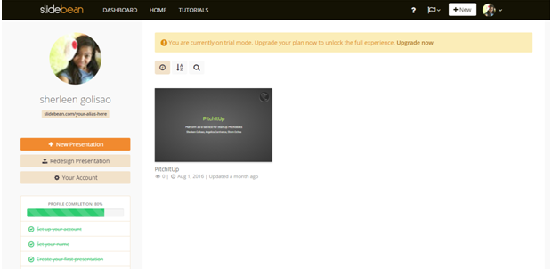

Figure 2: **Slidebean**

**About Slidebean**

Slidebean is a free web-based presentation tool that let the user create a powerful presentation with just a few clicks. By separating the content creation from the slide design, Slidebean allows users to focus on what matters most while taking care of everything else automatically.

It is a cloud-based platform, which makes it compatible with any modern browser in any operating system. The presentation that you started on your Mac will look the same on the PC you use to present, simply access to URL. This can also share slides with anyone and rest assures that a pitch deck will look as stunning it is meant to.

It has a combination of design templates, high-end color palettes and a premium selection of fonts, allows user to define the look of the presentation with the few clicks.

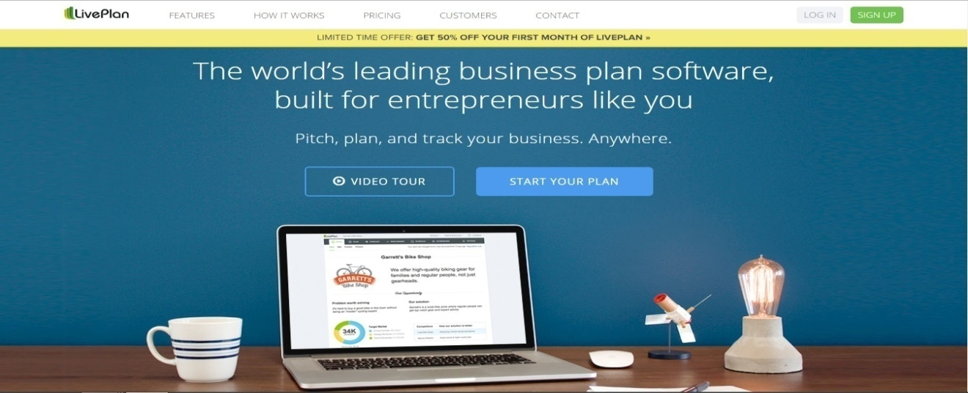

Figure 3: LivePlan

**About LivePlan**

LivePlan is for the entrepreneurs who need to develop a business plan, whether for a startup or an existing business. It does seem to cater more towards startups and companies seeking new funding.

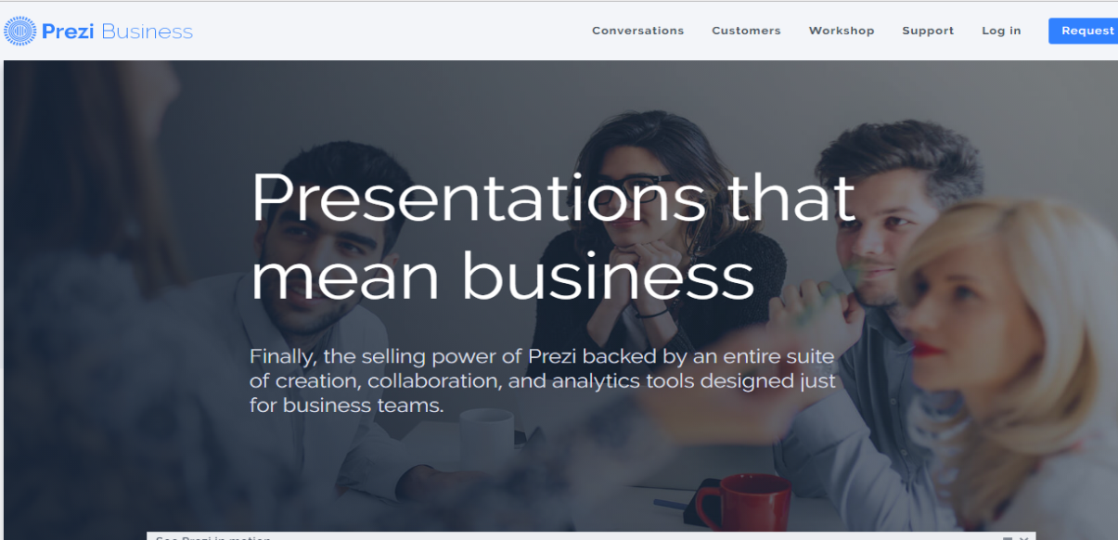

Figure 4: Prezi

**About Prezi**

**Prezi** is a cloud-based presentation software based on a software as a service model. The product employs a zooming user interface (ZUI), which allows users to zoom in and out of their presentation media, and allows users to display and navigate through information within a 2.5D or parallax 3D space on the Z-axis.

#### Comparative Matrix

The following tables shown below are the comparative matrices of the related studies of PitchITup.

Table 2

SLIDEBEAN

|  |  |  |  |  |
| --- | --- | --- | --- | --- |
| Related Studies | Features | Limitation | Platform Details | Support |
| Slidebean | -Share slides to anyone  -Embed any presentation on your website using a simple HTML script.  -The platform is built on a combination of HTML5 and Javascript. That means there's no need to install anything.  -Can request an export and get a copy of your slides in a matter of minutes. | -Cannot create pitch deck if you’re not log in to the account  -For pitch deck presentation only. | -Can run different Web browser.  -Can run in different operating system.  -Run in web and mobile Browser. | -Help startup founders to create pitch deck presentation. |

Table 3

LIVEPLAN

|  |  |  |  |  |
| --- | --- | --- | --- | --- |
| Related Studies | Features | Limitation | Platform Details | Support |
| Live Plan | -Plan- the foundation of your business  -Operate-  stay funded and healthy  -Grow-  insights to grow your business | -You have to be connected to the Internet to use LivePlan.  While you can develop more than one business plan, there is no way to copy an existing plan. | -LivePlan is a web application, you need to be connected to the Internet to use it. The good news is that you can use it from any computer or device with Internet access, so your software isn't stuck on a single PC. But currently we do not support offline access.  -Can run different Web browser. |  |

Table 4

PREZI

|  |  |  |  |  |
| --- | --- | --- | --- | --- |
| Related Studies | Features | Limitation | Platform Details | Support |
| Prezi | -Can insert pictures and videos  -Import Powerpoints  -It can create product to use for school projects  -It can add shapes to create places for information  -It can move text and rotate it to add depth in the presentation | - Text is Still Text, Bullet Points Still Don’t Work  -Allows Interesting Transitions Between Frames, but Within-Frame Animations are Limited  - The Canvas Provides a Spatial Framework for Organising Information – But Few Presentations Make Use of It Properly  - Frames in Prezi are Spatially Related Whether this Makes Sense or Not  - Nesting of Content Within Frames Mixes Spatial and Hierarchical Relationships, Which is Confusing for Audiences  - Default Settings Encourage Poor Practice | - Can run in different operating system  -Can run different Web browser.  -Can run Windows and Mac OS | - Creating presentation for business, individuals and student |

# CHAPTER III

## RESEARCH METHODOLOGY

### Software Engineering Methodology

**Agile Development Methodology**

This design is based on an incremental, iterative approach. Instead of in-depth planning at the beginning of the project. Agile methodologies are open to changing requirements over time and encourage constant feedback from the end users. Cross-functional teams work on iterations of a product over a period of time, and this work is organized into a backlog that is prioritized based on business or customer value. The goal of each iteration is to produce a working product.

In Agile methodologies, leadership encourages teamwork, accountability, and face-to-face communication. Business stakeholders and developers must work together to align the product with customer needs and company goals.

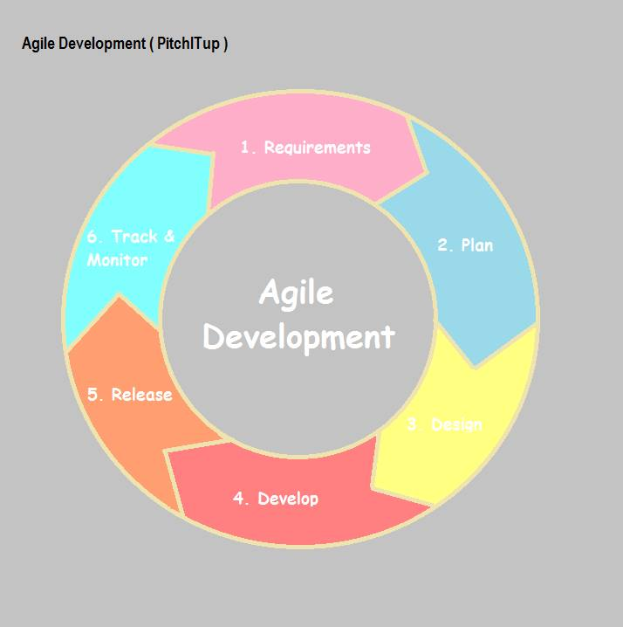

Figure 5: **Agile Development**

Here are the phases of the agile development cycle. It’s important to note that these phases shouldn’t happen in succession; they are flexible and always evolving. Many of these phases happen in parallel.

**Planning**

In this phase, this is how to break down the idea into smaller pieces of work (the features) then to prioritize each feature and assign it to iteration.

The planning of our system takes time for us to finalize everything most especially the designs and the flow and the output of the system.

**Requirements analysis**

In this phase, all possible requirements of the system to be developed are captured and documented in a requirement specification document.

The team makes sure that all the requirements needed in the PitchITup, is there and must be useful to the startup founders.

**Design**

In this phase, the requirement specifications from the first phase are studied and design is prepared. Design helps in specifying hardware and system requirements and also helps in defining overall system architecture.

The team decided to choose only two colors in this platform, which are light blue and white. We make sure that the user will be satisfied with in our design.

**Implementation, coding or development**

 In this phase, with inputs from design, the system is first developed in small programs called units, which are integrated into the next phase. Each unit is developed and tested for its functionality which is referred to as Unit Testing.

In developing the system, the team decided to use PHP programming, Laravel framework, and Bootstrap for the functionality of the system.

**Testing**

In this phase, all the units developed in the implementation phase are integrated into a system after testing of each unit.

The functionality of the system was tested and the team makes sure that the user will be satisfied and would like to use the platform.

**Deployment**

In this phase, once the functional and non-functional testing are done, the product is deployed in the customer environment or released into the market.

After PitchITup is tested, many startup founders would like to use it because it is a friendly user platform. The team will continue to develop the PitchITup for the user satisfaction.

### Planning/Conception-Initiation Phase

The Project Initiation Phase is the conceptualization of the project. This phase describes the basic processes that must be performed to start a new project. Its purpose is to specify what the project should accomplish.

In the PitchITup startup founder will fill up every detail needed in the pitch deck, the system itself will display the generated pitch deck.

#### Business Model Canvas

Business Model Canvas is a strategic management and lean startup template for developing new or documenting existing business models. It is a visual chart with elements describing a firm’s value proposition, infrastructure, customers, and finances. It assists firms in aligning their activities by illustrating potential trade-offs.

The Business Model Canvas was initially proposed by Alexander Osterwalder based on his earlier work on Business Model Ontology. Since the release of Osterwalder’s work in 2008, a new canvas for specific niches has appeared, such as the Lean Canvas.

The PitchITup Business Model canvas is shown in the figure below. It shows there every detail that the system needed and the systems purpose in developing this platform.

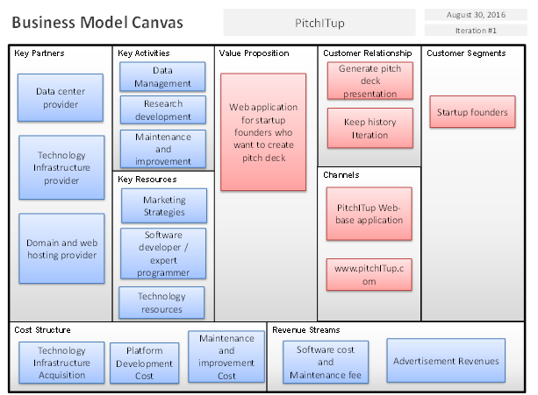

Figure 6: **Business Model Canvas**

#### Program Flow

It is the order in which individual statements, instructions or function calls of an imperative program are executed or evaluated. It is a statement whose execution results in a choice being made as to which of two or more paths should be followed. For non-strict functional languages, functions and language constructs exist to achieve the same result, but they are not necessarily called control flow statements.

The Program Flow of PitchITup is shown in the figure below, where startup founders can only use the platform through Web. The generated presentation can be Edited, or even share in social media. To make a pitch deck Internet connection is needed.

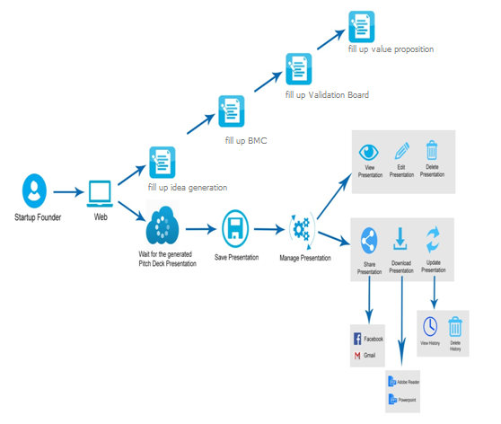

Figure 7: **Program Workflow for Startup Founder**

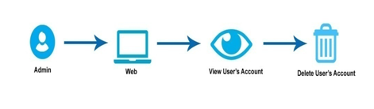

Figure 8: **Program Workflow for Admin**

#### Validation Board

It is a free tool to help entrepreneurs stay focused on taking action while implementing the Lean Startup process. It is used to test startup idea without wasting time or money.

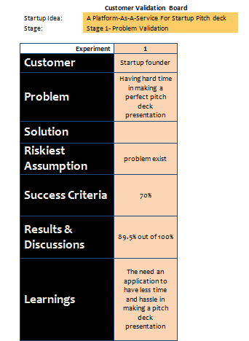

Figure 9: **Stage 1 of Problem Validation**

Based on the given data, it shows most of the startup founders having a hard time in making a perfect pitch deck. Some of them use a powerpoint, etc. in making a pitch deck presentation. It is more hassle and a waste of time.

We conclude that there’s a need to develop a system which is PitchITup, it will let the startup founder make a presentation by only fill up everything that is needed in the BMC, and the system will automatically generate a pitch deck presentation.

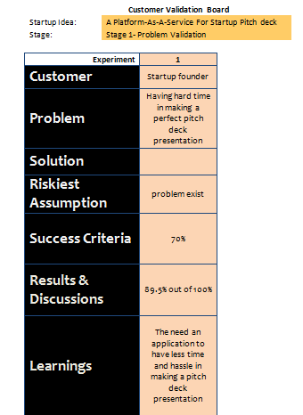

Figure 10: **Stage 2 of Problem Validation**

Based on this, we conclude that our startup idea would be a useful tool to help startup founders in making a pitch deck presentation.

#### Gantt Chart

A Gantt chart focuses primarily on project schedule management. It illustrates the start and finishes dates of the terminal and summary elements of the project.

The below figure shows how we manage to work on our system, each of the team has its own task to do.

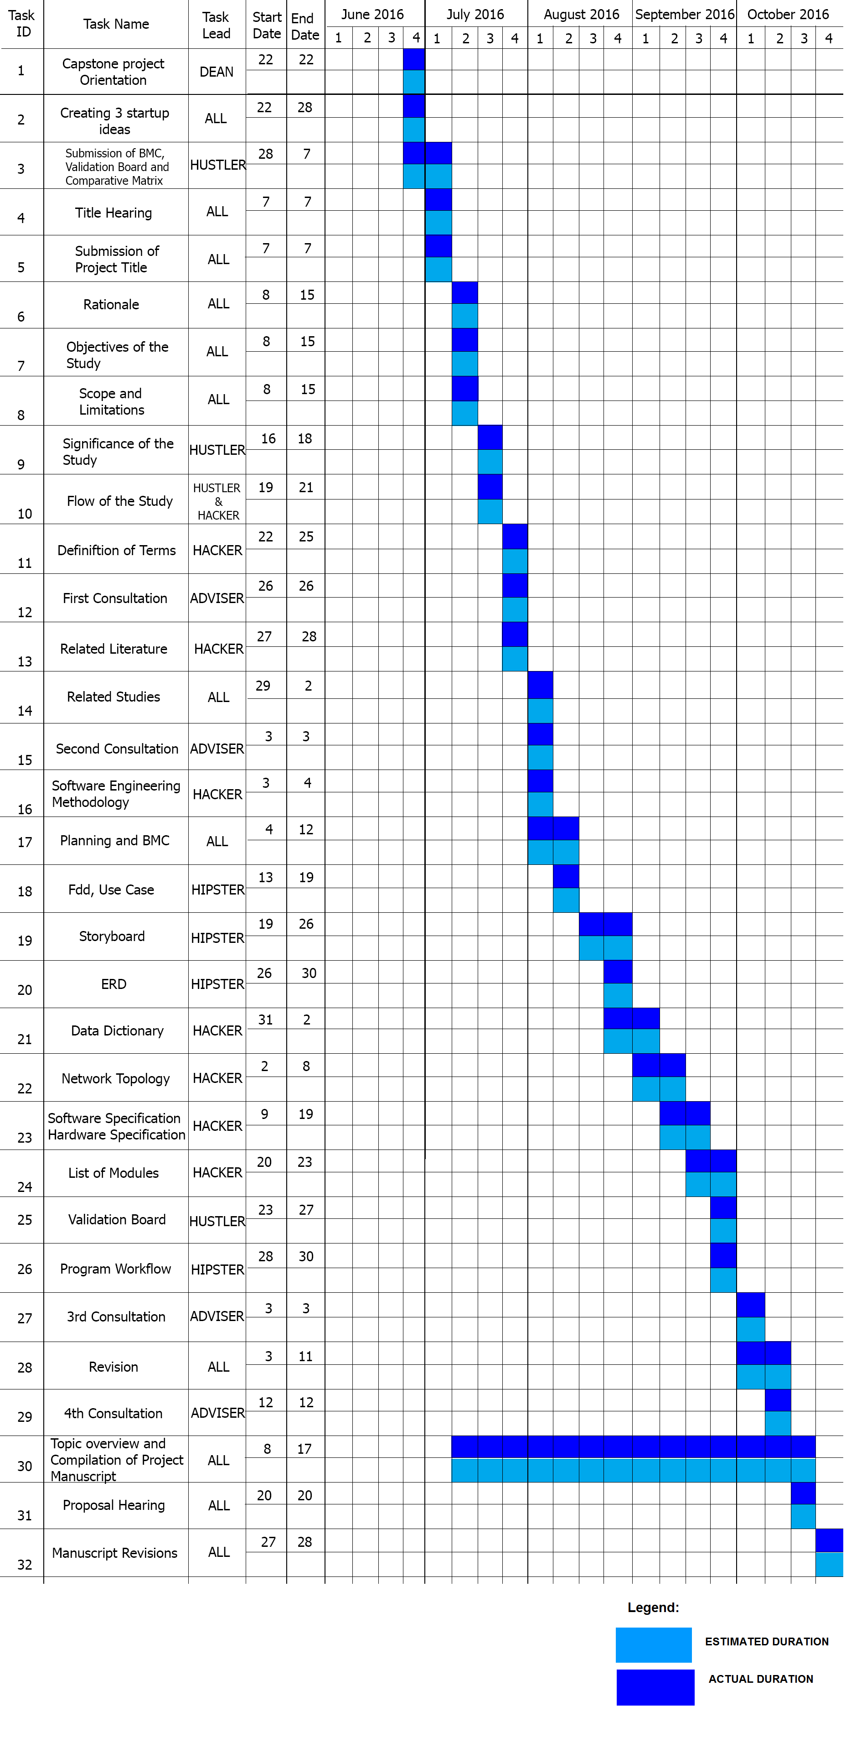

Figure 11: **Gantt Chart**

#### Functional Decomposition Diagram

**FDD** – show the structure of functions and process within the system. It is an alternative representation of the hierarchy of functions and process within a system. Functional decomposition is mostly used during the project analysis phase in order to produce functional decomposition diagrams as part of the functional requirements document.

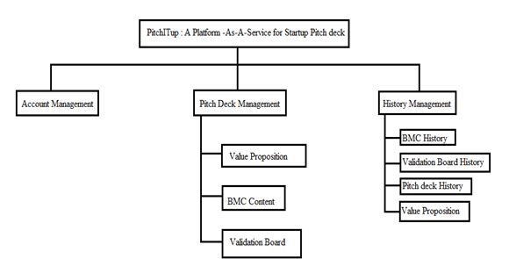

Figure 12: **Functional Decomposition Diagram**

The above figure is the FDD of PitchITup, it shows there how the system processedand how the system function.

### Analysis-Design Phase

The Analysis Phase is where the project lifecycle begins. It is where you break down the deliverables in the high-level Project Charter into the more detailed business requirements.

#### Use Case Diagrams

Use Case Diagram are usually referred to as behavior diagram used to describe a set of actions (use cases) that system should or can perform in collaboration with one or more external users of the system (actors). Each use case should provide some observable and valuable result to the actors or other stakeholders of the system.

The PitchITup Use Case Diagram is shown in the figures below, which describes how the startup founders use the system and how the system perform on this platform.

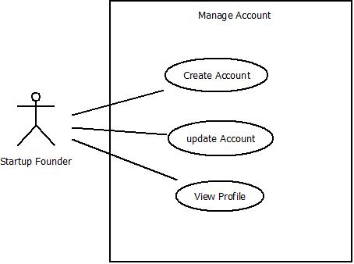

Figure 13: **Startup founder account management**

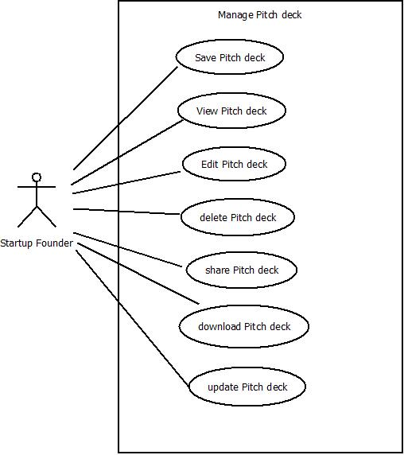

Figure 14: **Pitch Deck Management**

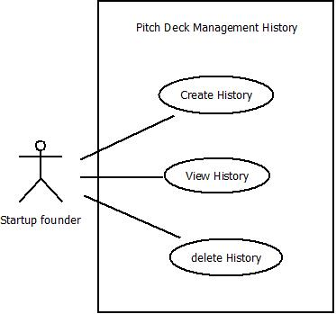

Figure 15: **Pitch Deck History Management**

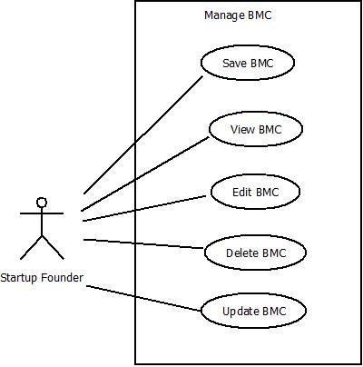

Figure 16: **BMC Management**

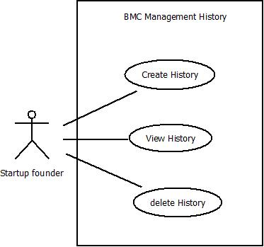

Figure 17: **BMC History Management**

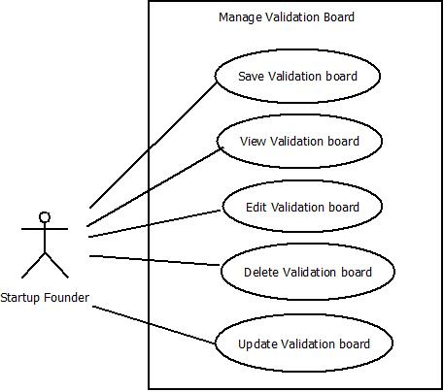

Figure 18: **Validation Board Management**

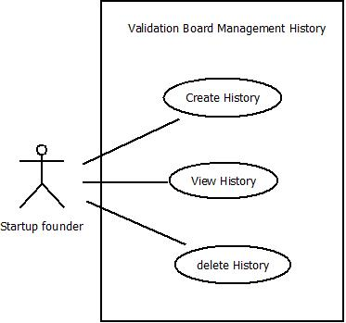

Figure 19: **Validation Board History Management**

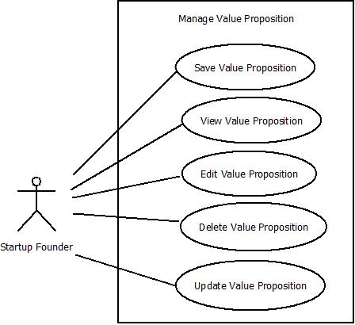

Figure 20: **Value Proposition Management**

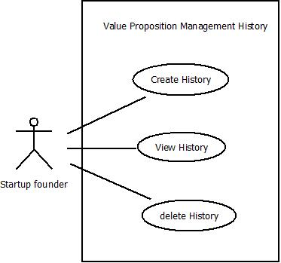

Figure 21: **Value Proposition History Management**

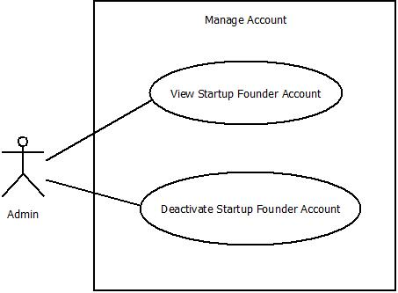

Figure 22: **Admin Account Management**

#### Storyboard

To get started, startup founders must visit our website and see what our platform is all about.

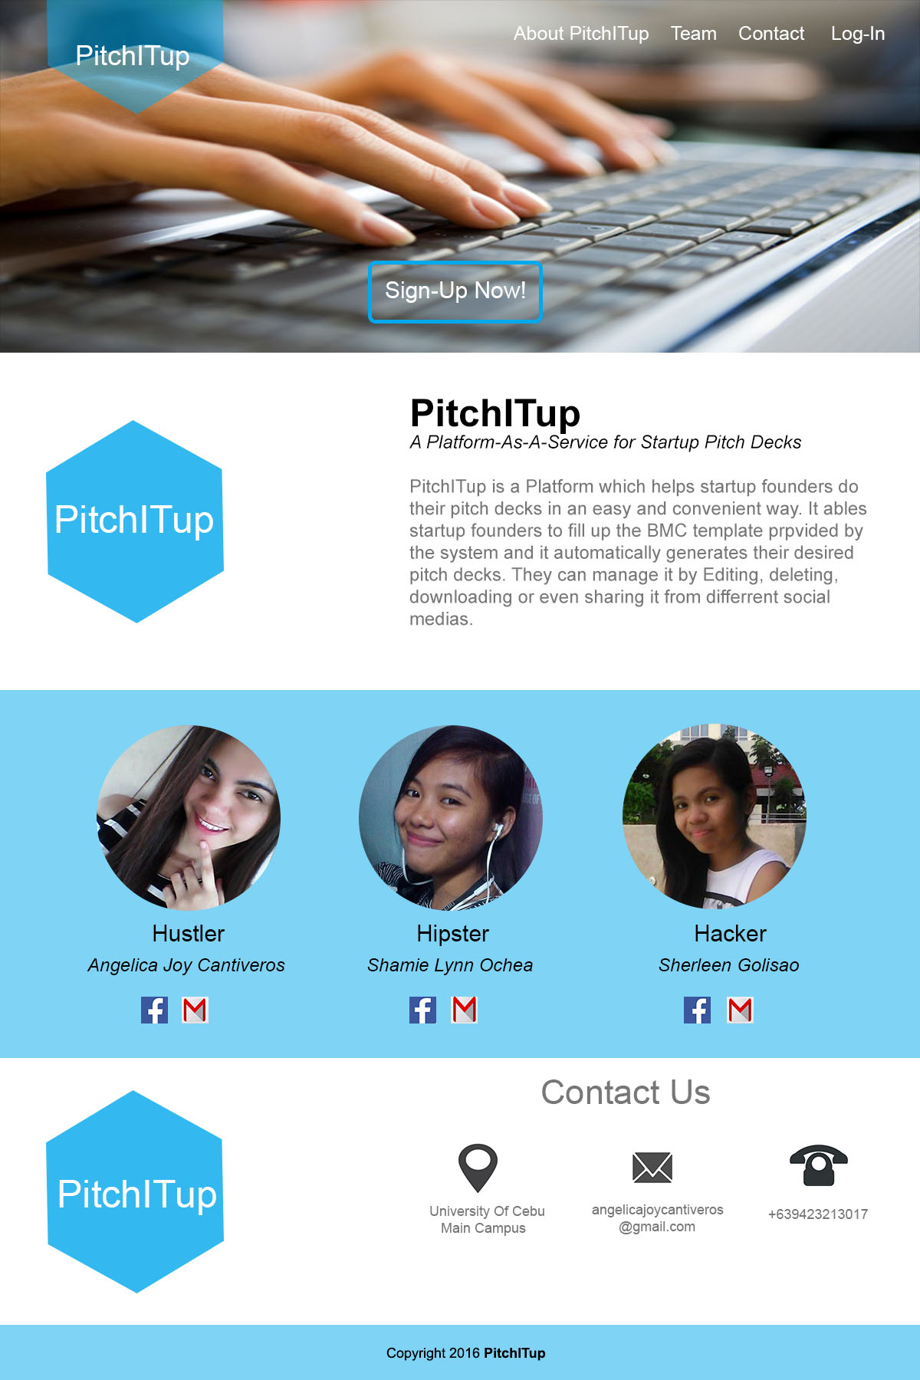

Figure 23: **Homepage Interface**

In the above figure is our homepage interface where startup founders will know about our platform, the team behind it, and our contact information. If they are interested regarding our platform they can click the Sign-Up Now button to proceed to the registration process.

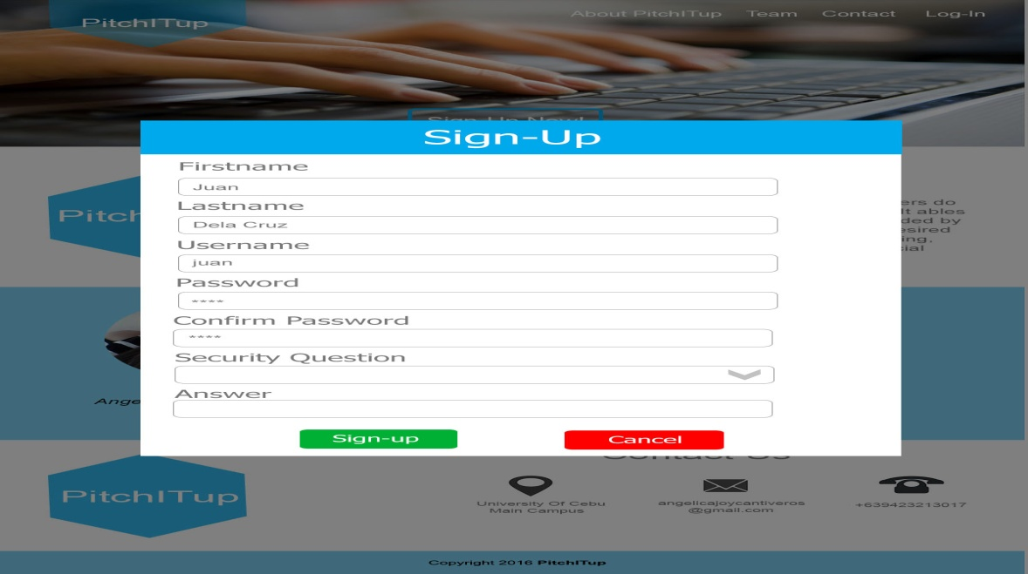

Figure 24: **Sign-up Form**

The figure above is our Sign-Up page, where startup founders should fill up all information needed. All the information above is important and they should remember what they answered. If one information is not answered the sign-up process will not be successful.

After the registration process, startup founders must login their username and password.

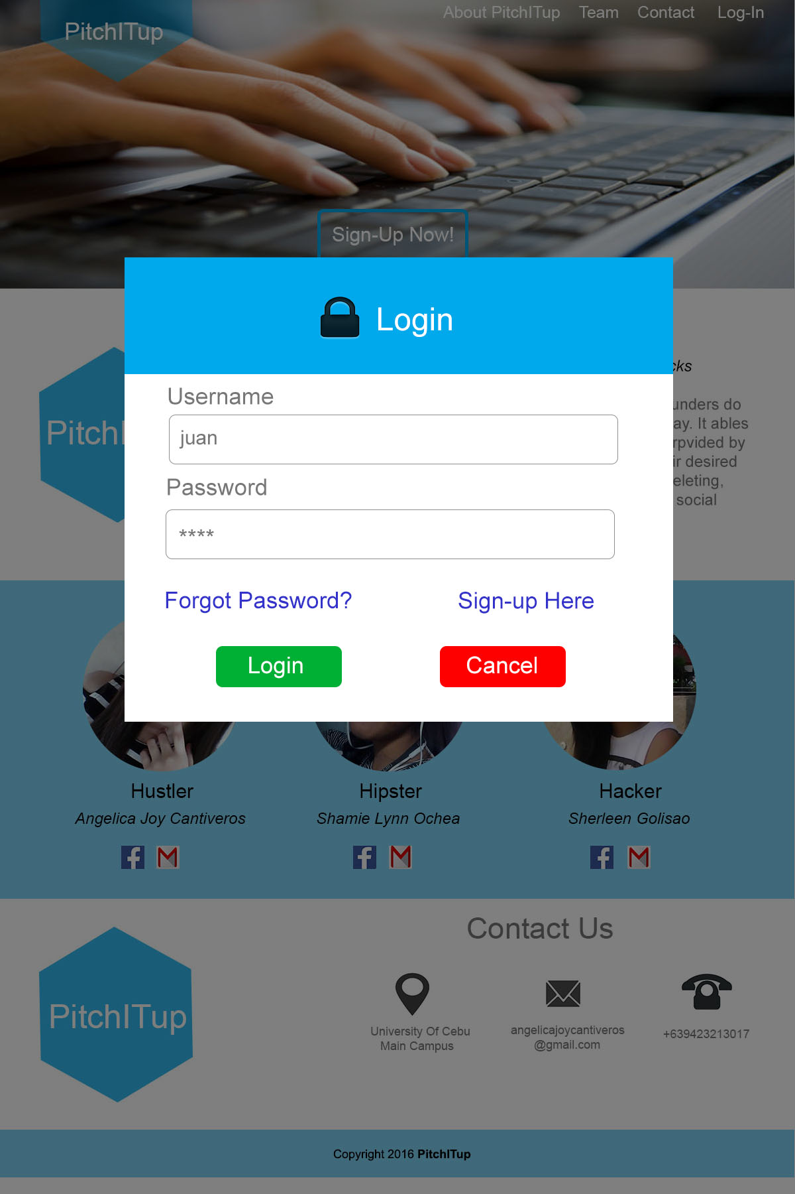

Figure 25: **Login Form**

In case they forgot their password, the security question is a big help for them, they must remember what they answered the security question for us to retrieve their password. The security question serves as their protection if someone will try to access their account and also their backup when they forgot their password.

This is how it looks like after logging in to your account. To start creating a pitch deck, click the Get Started Button.

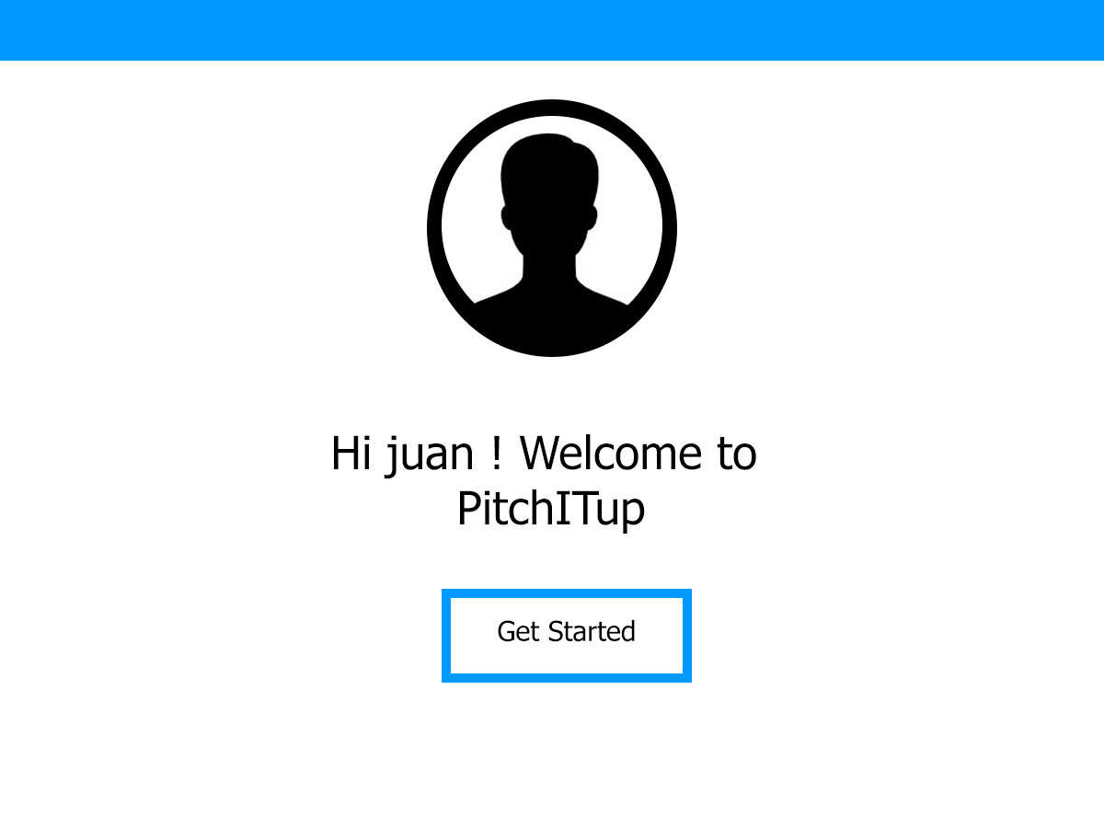

Figure 26: **Get Started Interface**

The below figure is the startup founders Homepage, where no display found when they haven’t make a pitch deck.

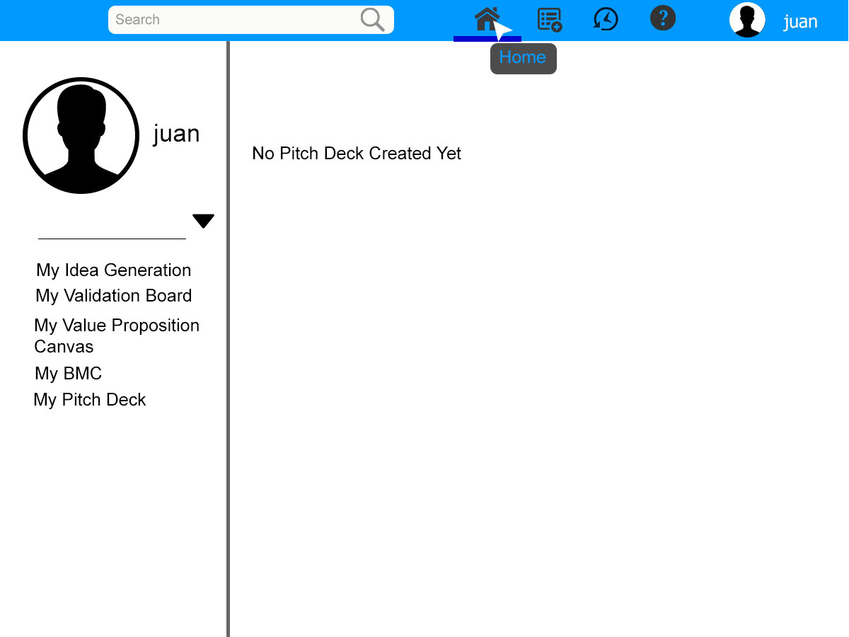

Figure 27: **Home Interface**

In creating a pitch deck the figure below shows to click the icon on the page, which looks like a document icon. When the startup founder clicks the create icon the first step in creating a pitch deck will display first and in there they will fill up every detail needed in the idea generation board. After done putting the information, click the arrow below to proceed to the next step.

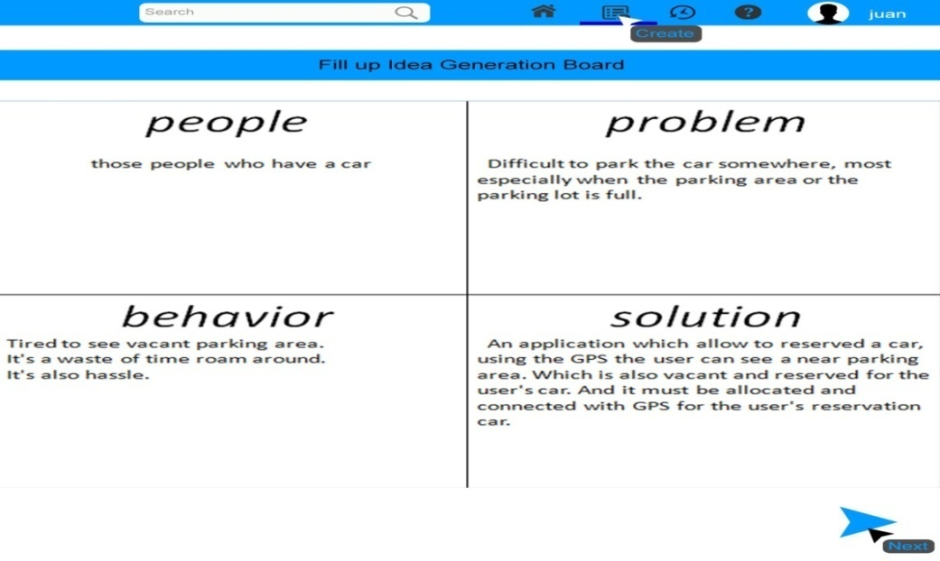

Figure 28: **Create Idea Generation Board Interface**

Validation Board would be the next step to do. The same procedure as the first step, to fill up every detail needed in the pitch deck. If ever you want to go back to the first step, which is the Idea generation board you can click the preview icon which is located at the left corner of the page. When everything is done, click the next icon to proceed to the next step.

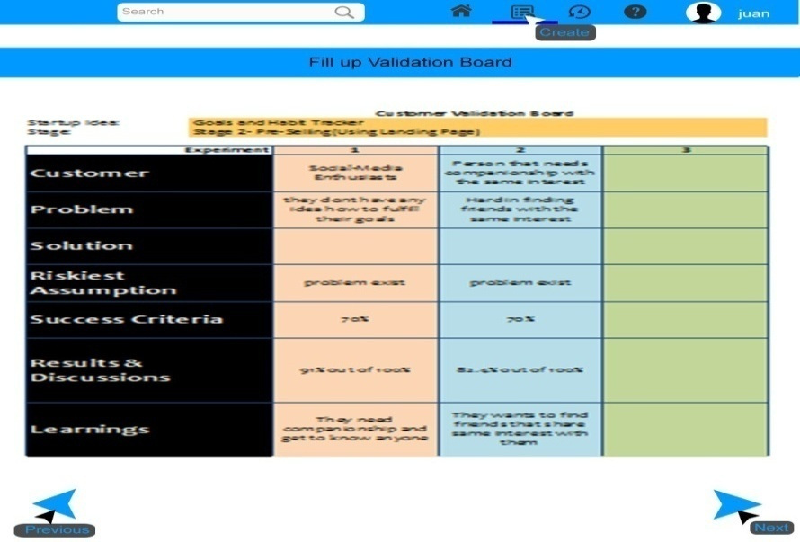

Figure 29: **Create Validation Board Interface**

After putting details in the Validation Board, The figure shown below is a Value proposition. The same step is also done here.

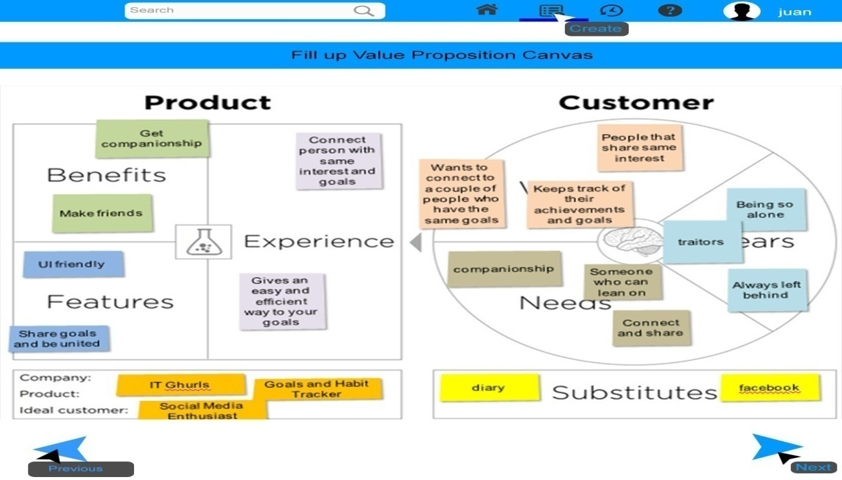

Figure 30: **Create Value Proposition Interface**

The below figure is the last step of gathering information to create a pitch deck. All the information below is required, if one information is missing the PitchITup will not continue to generate a pitch deck. After everything is filled up, click the Next icon to proceed to the next step, which is generating a pitch deck.

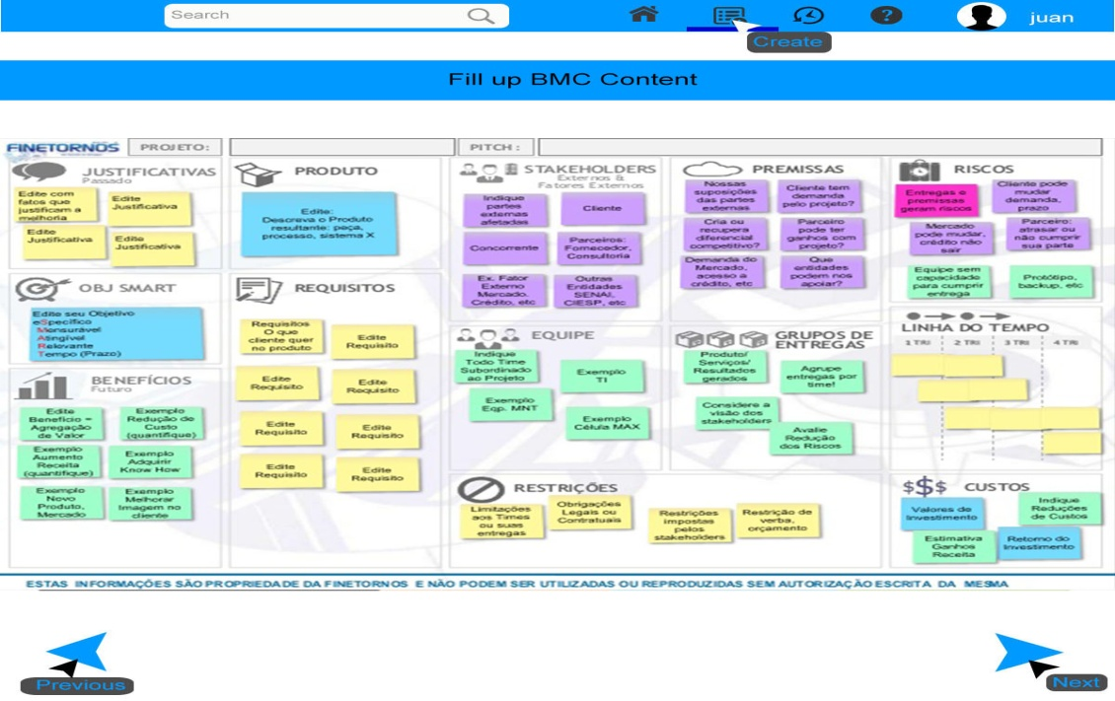

Figure 31: **Create BMC Content Interface**

The figure below shows the loading process.Wait until the generated pitch deck is completed.

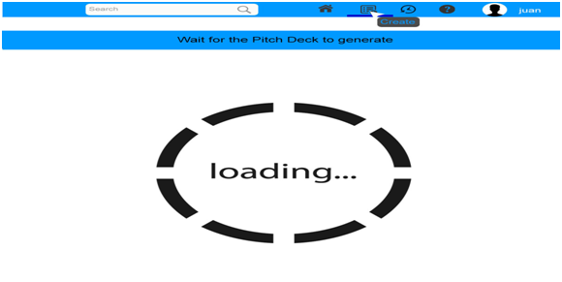

Figure 32: **Generate Pitch Deck Interface**

When the process is complete, the generated pitch deck will look like the figure below. In this page, you can view your pitch deck.

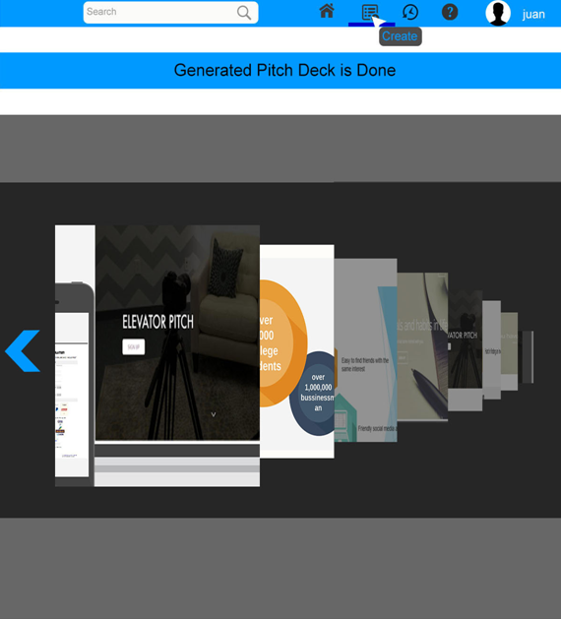

Figure 33: **Pitch Deck Interface**

When the startup founder already created a pitch deck, the home will look like the figure below. It will display every detail you created in your account.

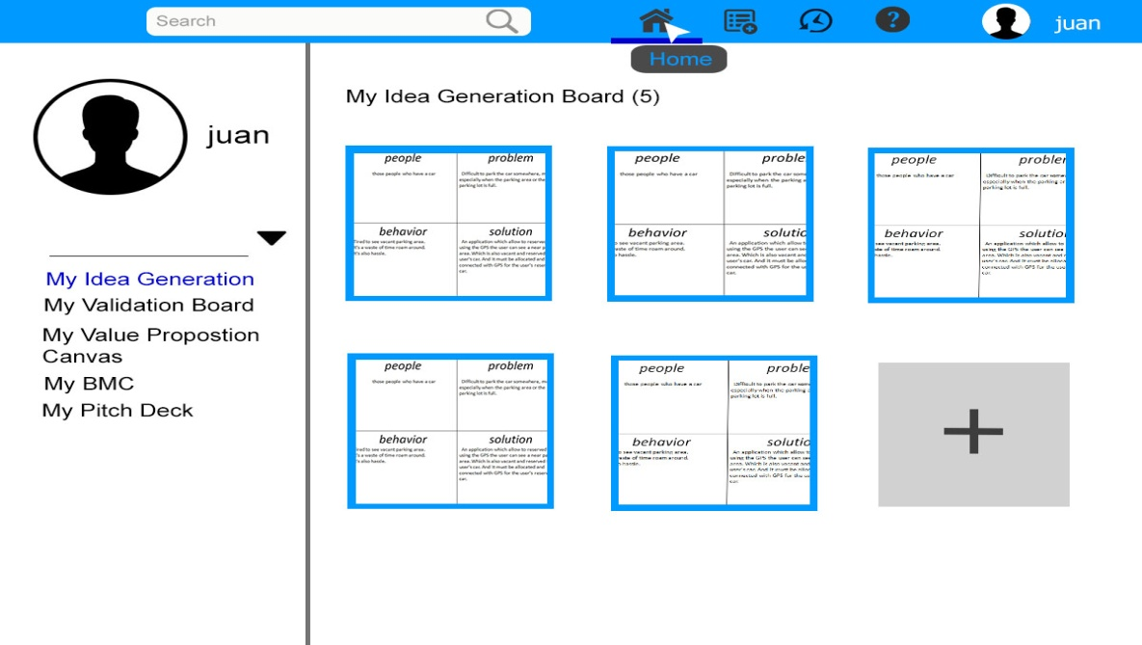

Figure 34: **Idea Generation Interface**

When you want to view, revise, and delete something in your pitch deck. They can click the icons that shown in the figure below.

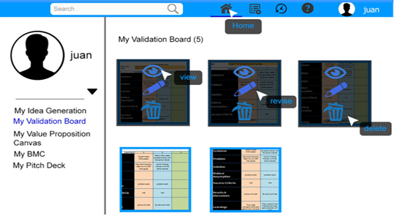

Figure 35: **Validation Board Interface**

When the startup founder would like to share and download their pitch deck they can go to My Pitch Deck page and then click the share or download icon which is located when they will click the pitch deck presentation. The figure below shows where the icons are located.

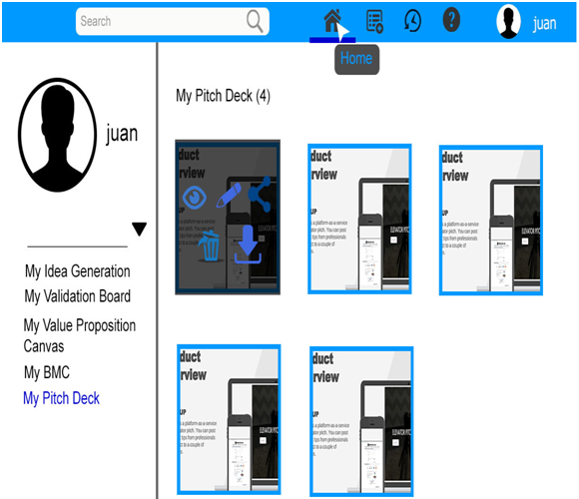

Figure 36: **Value Proposition Interface**

The figure below shows how the download process looks like when the startup founders click the download icon.

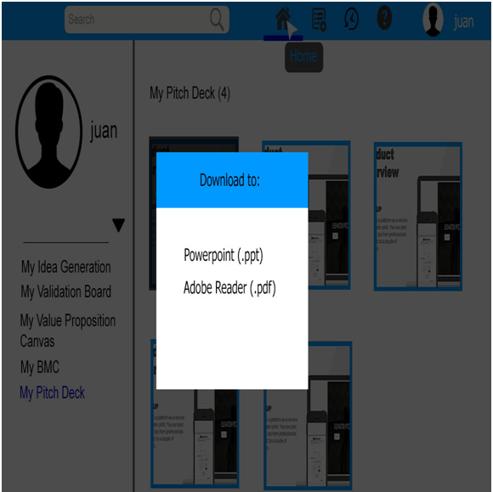

Figure 37: **Download Interface**

And the figure that shown below is how the share looks like when the startup founders click the share icon.

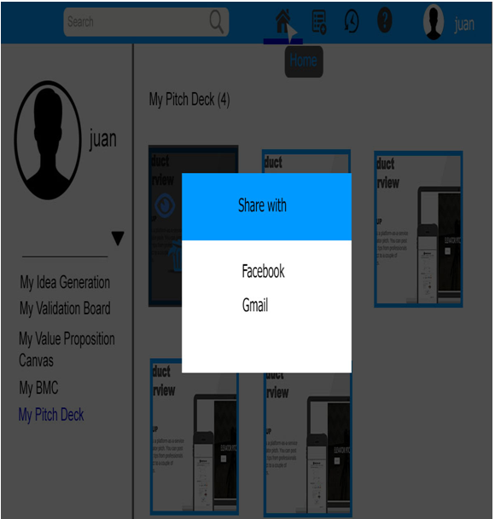

Figure 38: **Share Interface**

Making changes in the account is in the upper-rightpart of the screen, where the startup founders name is located. After done make changes of the account, click the Save button to saved the changes.

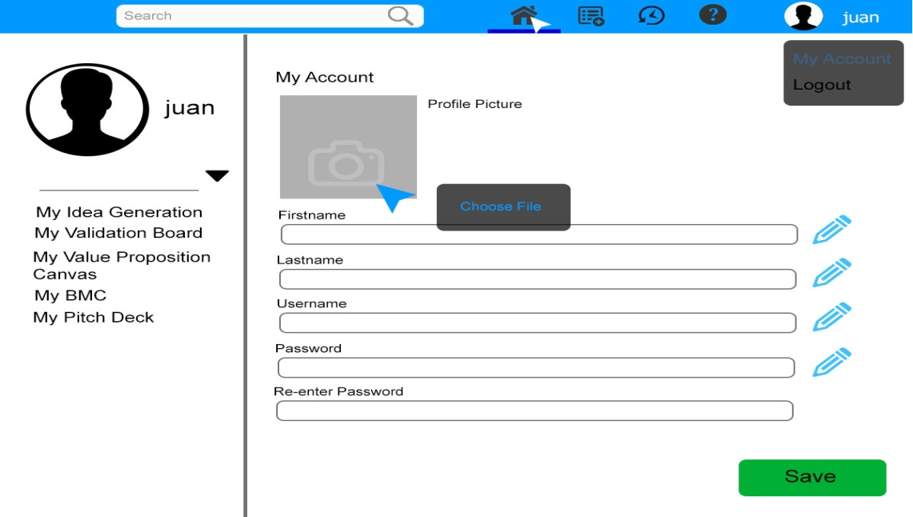

Figure 39: **My Account Interface**

The history of the Validation Board, BMC, Value Proposition Canvas and Pitch Deck is found in the upper part of the screen where the history icon is located.

The below figures will show how our platform displays the history.

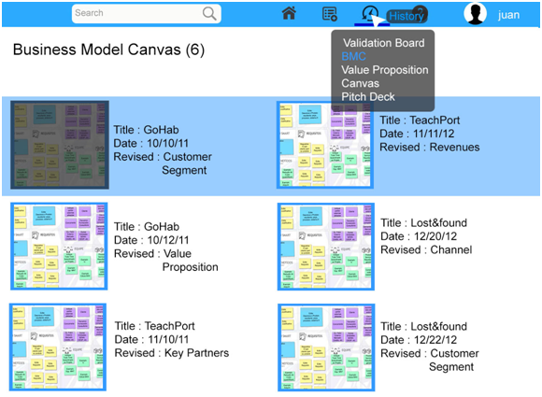

Figure 40: **BMC History Interface**

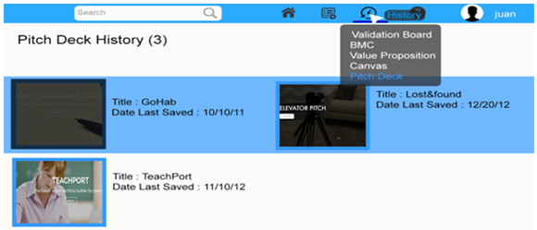

Figure 41: **Pitch Deck History Interface**

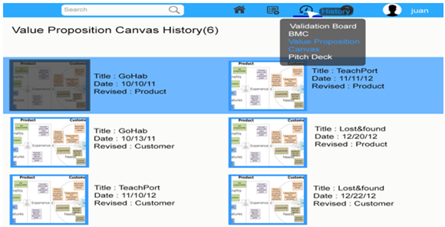

Figure 42: **Value Proposition Canvas History Interface**

The figure below shows where the delete and view icons are located.

Deleting and viewing the created Pitch deck, BMC, etc. is also found in the history page.

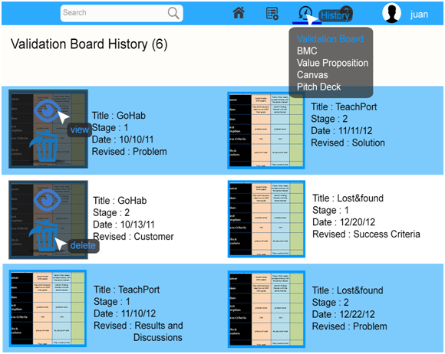

Figure 43: **Validation Board History Interface**

The help icon is located at the upper right of the screen, which shows in the figure below.

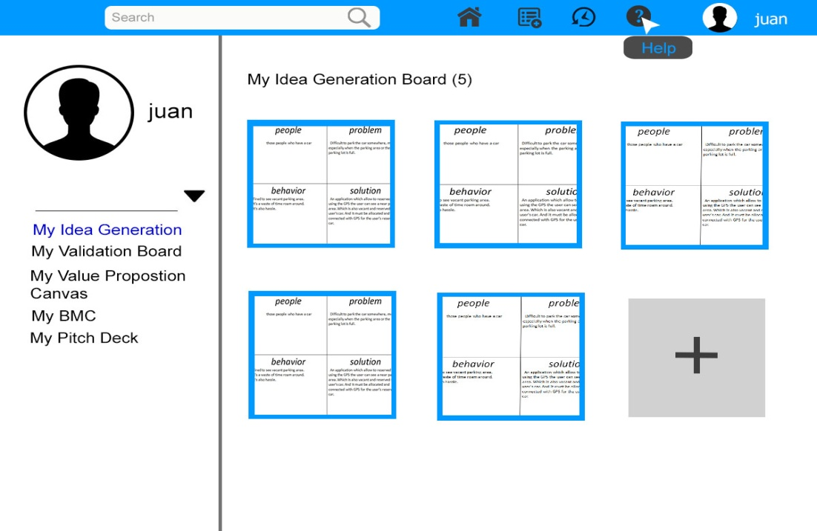

Figure 44: **Help Interface**

Logging out to this page is located at the upper-right part of the screen where the startup founders name is located. Click the logout button to close your account.

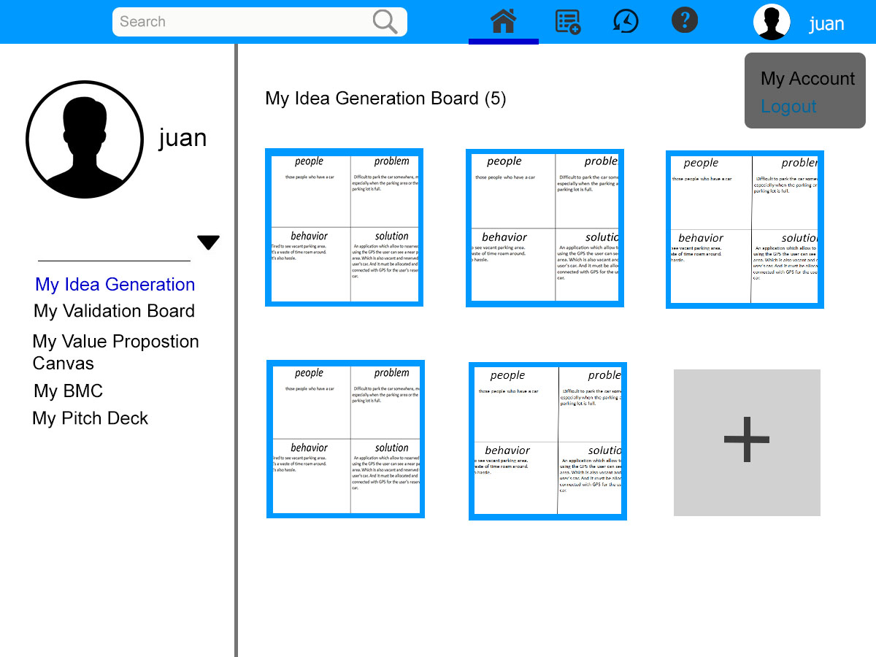

Figure 45: **Idea Generation Board Interface**

#### Database Design

##### **Entity-**

##### **Diagram**

An entity – relationship diagram (ERD) is a conceptual and representational model of data used to represent the entity framework infrastructure. It is used as a high-level logical data model, which is useful in developing a conceptual design for the database (Li &Chen, 2009).

s

Figure 46: **Entity-Relationship Diagram**

The database of the PitchITup is shown in the figure above, where it shows how the data interacts together and how the system works.

##### **Data Dictionary**

Data dictionary or metadata defines the structure of the database itself and is used in control and maintenance of large databases. Data dictionary contains a list of all files in the database, the number of records in each file, and the names and types of each field.

Table 4

STARTUP FOUNDER

|  |  |  |  |  |
| --- | --- | --- | --- | --- |
| Field Name | Description | Data Type | Length | Nullable |
| SF_id | Primary Key, unique Startup founder record identifier, auto-generated | Int |  | No |
| Firstname | Startup founder’s firstname | Varchar | 50 | No |
| Lastname | Startup founder’s lastname | Varchar | 50 | No |
| Username | Startup founder’s username | Varchar | 20 | No |
| Password | Startup founder’s password | Varchar | 25 | No |
| Security_Answer | Security Answer | Varchar | 15 | No |
| Security_question | Security Question | Varchar | 15 | No |

Table 5

Business Model Canvas

|  |  |  |  |  |
| --- | --- | --- | --- | --- |
| Field Name | Description | Data Type | Length | Nullable |
| BMC_id | Primary Key, unique BMC record identifier, auto-generated | Int |  | No |
| Problem | Problem | Varchar | 50 | No |
| Customer_Segment | Customer Segment | Varchar | 100 | No |
| Customer_Relationship | Customer Relationship | Varchar | 100 | No |
| Channels | Channels | Varchar | 100 | No |
| Value_Proposition | Value Proposition | Varchar | 250 | No |
| Key_Activities | Key Activities | Varchar | 100 | No |
| Key_Resources | Key Resources | Varchar | 100 | No |
| Key_Partners | Key Partners | Varchar | 100 | No |
| Cost_Structure | Cost Structure | Varchar | 100 | No |
| Revenue_Streams | Revenue Streams | Varchar | 100 | No |
| History_id | Foreign key, reference(Hstory_id) | Int |  | No |

Table 6

Value_Proposition

|  |  |  |  |  |
| --- | --- | --- | --- | --- |
| Field Name | Description | Data Type | Length | Nullable |
| Value_id | Primary Key, unique Value Proposition record identifier, auto-generated | Int |  | No |
| Wants | Customer Wants | Varchar | 80 | No |
| Needs | Customer Needs | Varchar | 50 | No |
| Fears | Customer Fears | Varchar | 50 | No |
| Benefits | Product Benefits | Varchar | 100 | No |
| Experience | Product Experience | Varchar | 100 | No |
| Features | Product Features | Varchar | 100 | No |
| Company | Company | Varchar | 100 | No |
| Product | Product | Varchar | 100 | No |
| Ideal_Customer | Ideal Customer | Varchar | 100 | No |
| Substitutes | Substitutes | Varchar | 100 | No |
| History_id | Foreign key, reference(History_id) | Int |  | No |

Table 7

Validation_Board

|  |  |  |  |  |
| --- | --- | --- | --- | --- |
| Field Name | Description | Data Type | Length | Nullable |
| Valid_id | Primary Key, unique Validation board record identifier, auto-generated | Int |  | No |
| Customer | Customer | Varchar | 80 | No |
| Problem | Problem | Varchar | 50 | No |
| Solution | Solution | Varchar | 50 | No |
| Riskiest_Assumption | Riskiest_Assumption | Varchar | 100 | No |
| Solution_Criteria | Solution_Criteria | Varchar | 100 | No |
| Results | Results | Varchar | 100 | No |
| Learnings | Learnings | Varchar | 100 | No |
| History_id | Foreign key, reference(History_id) | Int |  | No |

Table 8

GENERATED_PITCH_DECK

|  |  |  |  |  |
| --- | --- | --- | --- | --- |
| Field Name | Description | Data Type | Length | Nullable |
| Pitch_deck_id | Primary Key, unique pitch deck record identifier, auto-generated | Int |  | No |
| Num_of_Pitch_deck | Pitch deck Number | Int | 15 | No |
| idea_id | Foreign key, reference(Idea_id) | Int |  | No |
| Valid_id | Foreign key, reference(Valid_id) | Int |  | No |
| BMC_id | Foreign key, reference(BMC_id) | Int |  | No |

Table 9

IDEA_GENERATIONBOARD

|  |  |  |  |  |
| --- | --- | --- | --- | --- |
| Field Name | Description | Data Type | Length | Nullable |
| Idea_id | Primary Key, unique Idea Generation Board record identifier, auto-generated | Int |  | No |
| Problem | Problem | Varchar | 150 | No |
| People | People | Varchar | 50 | No |
| Behavior | Behavior | Varchar | 100 | No |
| Solution | Solution of the problem | Varchar | 200 | No |
| SF_id | Foreign key, reference(SF_id) | Int |  | No |

Table 10

HISTORY

|  |  |  |  |  |
| --- | --- | --- | --- | --- |
| Field Name | Description | Data Type | Length | Nullable |
| history_id | Primary Key, unique history record identifier, auto-generated | Int |  | No |
| Date_LastViewed | Date Last Viewed | Date |  | No |
| Date_LastModified | Date Last modified | Date |  | No |
| Time | Time | Time |  | No |

#### Network Design

##### **Network Model**

A network model is a database model that is designed as a flexible approach to representing objects and their relationships. A unique feature of the network model is its schema, which is viewed as a graph where relationship types are arcs and object types are nodes. Unlike other database models, the network model's schema is not confined to be a lattice or hierarchy; the hierarchical tree is replaced by a graph, which allows for more basic connections with the nodes

##### **Network Topology**

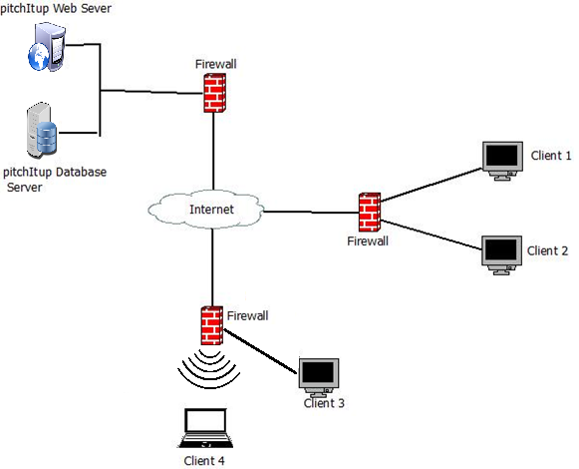

Figure 47: **Network Topology**

The above figure shows the network topology of the proposed system which is the star topology, in which all nodes are individually connected to a central point, like a hub or a switch. If the cable fails, only one node will be brought down. The central site is control of all the nodes attached to it. The central hub is usually a fast, self-contained computer and is responsible for routing all traffic to other nodes. One malfunctioning node does not affect the rest of the network, it is easy to detect the problem and troubleshoot it.

### Developing/Construction/Build Phase

#### Technology Stack Diagram

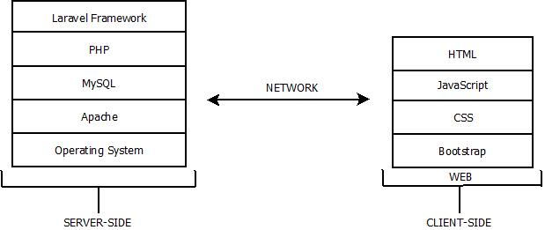

Figure 48: **Technology Stack Diagram**

##### **Software Specification**

The researchers determine the Software Specifications to familiarize the specifications needed for the system.

Table 11

SOFTWARE SPECIFICATION

|  |  |
| --- | --- |
| Operating System | Windows 7 and above |
| Web browsers | Mozilla Firefox, Google Chrome, Internet explorer |
| Server Package | XAMPP 3.2.1 |
| Web development tool | JQUERY, PHP framework, HTML 5, CSS, JavaScript, Bootstrap, Database MySQL |
| Text editing tool | Sublime 2 |

##### **Hardware Specifications**

The hardware specifications are the tangible components of a system that would define the requirements of its hardware peripherals so that the system will be capable of its expected functions.

Table 12

HARDWARE SPECIFICATION

|  |  |
| --- | --- |
| **Monitor** | LCD or CRT Monitors LED |
| **Mouse** | Optical or Laser Mouse |
| **Keyboard** | Generic Keyboard |
| **Processor** | Intel core i7 processor |
| **Hard Disk Drive** | 1 TB Hard Disk |
| **Memory/RAM** | 16GB RAM |
| **Operating System** | Windows XP or Above Operating System |

The researchers determine the Hardware Specifications in order to be familiar with the specifications needed for the system to be fully functional.

#### Program Specification

##### **List of Modules**

Table 13

List of Modules

|  |  |  |  |  |  |
| --- | --- | --- | --- | --- | --- |
| Programmer | | Modules | Administrator | | Startup Founder |
|  | | **Account Management** |  | |  |
|  | | Create |  | | * |
| Sherleen Golisao | | Deactivate | * | |  |
|  | | View | * | | * |
|  | | Update |  | | * |
|  | No. of Points (*1 point for module user*) | | | 1 | 1 |
|  | | **Pitch Deck Management** | |  |  |
|  | | View | |  | * |
| Sherleen Golisao | | Edit | |  | * |
|  | | Download | |  | * |
|  | | Share | |  | * |
| Save | |  | * |
| Delete | |  | * |
|  | No. of Points (1 point for module user) | | |  | 1 |
|  | | **BMC Management** | |  |  |
|  | | View | |  | * |
| Sherleen Golisao | | Edit | |  | * |
| Save | |  | * |
| Delete | |  | * |
|  | No. of Points (1 point for module user) | | |  | 1 |
|  |  | **Validation Board Management** | |  |  |
| Sherleen Golisao | | View | |  | * |
| Edit | |  | * |
| Save | |  | * |
| Delete | |  |  |
|  | No. of Points (1 point for module user) | | |  | 1 |
| Sherleen Golisao | | **Value Proposition Management** | |  |  |
| View | |  | * |
| Edit | |  | * |
| Save | |  | * |
| Delete | |  | * |
| No. of Points (1 point for module user) | | | |  | 1 |
| Sherleen Golisao | | **History Management** | |  |  |
| Create | |  | * |
| View | |  | * |
| Delete | |  | * |
| No. of Points (1 point for module user) | | | |  | 1 |
|  | No. of Modules per User (*total no. points per user*) | | | 1 | 6 |
|  | | Total Number of Modules | |  | 7 |

# REFERENCES

*agileme thodology*. (n.d.). Retrieved August 7, 2016, from agilemethodology.org: http://agilemethodology.org/

*Cayenne Consulting*. (n.d.). Retrieved 8 2016, August, from www.caycon.com: https://www.caycon.com/pitch-deck-design.php

*Improve presentattion*. (n.d.). Retrieved July 20, 2016, from pitchdeck.improvepresentation.com: https://pitchdeck.improvepresentation.com/what-is-a-pitch-deck

*LivePlan*. (n.d.). Retrieved August 7, 2016, from www.liveplan.com: https://www.liveplan.com/?pm=HALFOFFMONTH1&utm_source=google&utm_medium=cpc&utm_term=Live%2520plan&utm_campaign=liveplan_brand_alpha&gclid=COTDv5CW488CFUxvvAodPfgOIw

Parsons, N. (n.d.). The 11 Slides You Need to Have in Your Pitch Deck. pp. http://articles.bplans.com/what-to-include-in-your-pitch-deck/.

*searchnetworking.techtarget.com*. (n.d.). Retrieved August 7, 2016, from searchnetworking: http://searchnetworking.techtarget.com/definition/baseboard-management-controller

Skok, D. (n.d.). *for entrepreneurs*. Retrieved july 7, 2016, from http://www.forentrepreneurs.com/: http://www.forentrepreneurs.com/why-startups-fail/

*Slidebean*. (n.d.). Retrieved July 10, 2016, from slidebean.com: http://slidebean.com/?utm_source=Google-WW-BrandedSearch&utm_campaign=Google-WW-BrandedSearch&gclid=CIvFsJSV488CFQwJvAodjQQPxw

*slidebean.com*. (n.d.). Retrieved August 8, 2016, from slidebean: http://slidebean.com/blog/startups/airbnb-pitch-deck

*SmartSheet*. (n.d.). Retrieved August 7, 2016, from www.smartsheet.com: https://www.smartsheet.com/agile-vs-scrum-vs-waterfall-vs-kanban

*TechTarget*. (n.d.). Retrieved August 10, 2016, from searchsoftwarequality.techtarget.com: http://searchsoftwarequality.techtarget.com/definition/Gantt-chart

# 

# CURRICULUM VITAE

**Angelica Joy Cantiveros**

**Hustler**



**PERSONAL DATA**

Name : Angelica Joy Cantiveros

Address : TayudConsolacion Cebu

Sex : Female

Date of Birth : February 6, 1996

Civil Status : Single

Citizenship : Filipino

Email Address : cantiverosangelicajoy@gmail.com

**EDUCATIONAL ATTAINMENT**

College Bachelor of Science in Information Technology

University of Cebu – Main

Sanciangko St., Cebu City

Secondary St. Cecilia’s College Cebu Inc.

Poblacion Ward II Tiber Minglanilla Cebu

Elementary Tungkop Elementary School

TungkopMinglanilla Cebu

**Sherleen Golisao**

**Hacker**



**PERSONAL DATA**

Name : SherleenGolisao

Address : Pusok Seaside Lapu-lapu City

Sex : Female

Date of Birth : January 22, 1997

Civil Status : Single

Citizenship : Filipino

Email Address : sherleengolisao@gmail.com

**EDUCATIONAL ATTAINMENT**

College Bachelor of Science in Information Technology

University of Cebu – Main

Sanciangko St., Cebu City

Secondary PusokNational High School

Matumbo, Pusok, Lapu-lapu City

Elementary Pusok Elementary School

PusokLapu-lapu City

**Shamie Lynn Ochea**

**Hipster**



**PERSONAL DATA**

Name : Shamie Lynn Ochea

Address : SitioLoardes, Cogon Pardo, Cebu City

Sex : Female

Date of Birth : July 13, 1996

Civil Status : Single

Citizenship : Filipino

Email Address : shamiesham13@gmail.com

**EDUCATIONAL ATTAINMENT**

College Bachelor of Science in Information Technology

University of Cebu – Main

Sanciangko St., Cebu City

Secondary RondaNational High School

Poblacion, Ronda, Cebu

Elementary Butong Elementary School

Butong, Ronda, Cebu

# APPENDICES

**APPENDIX A: Oath of Confirmation**

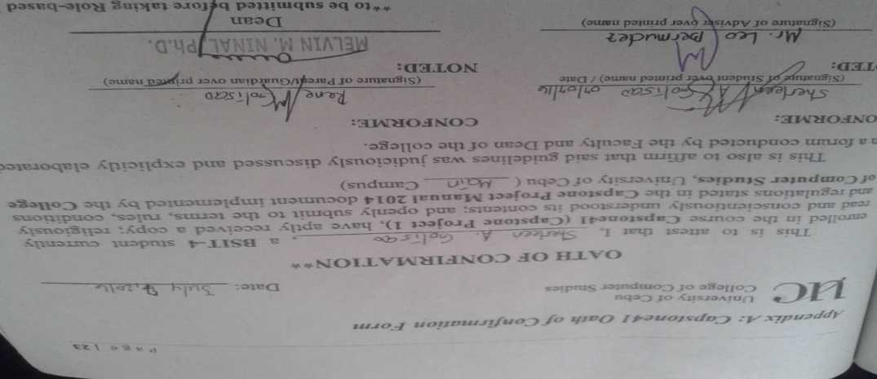

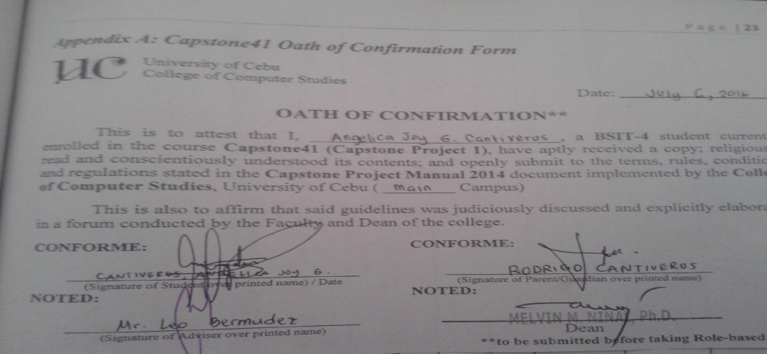

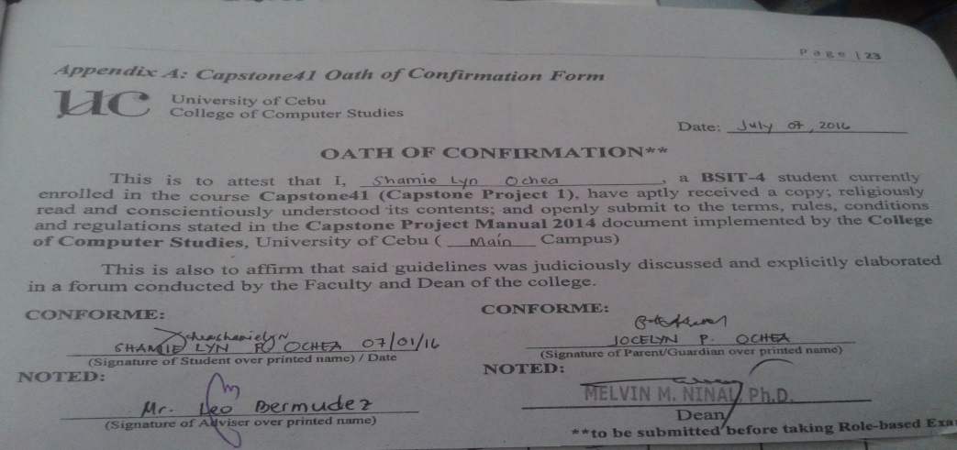

**APPENDIX B: Capstone Project Team Composition Form**

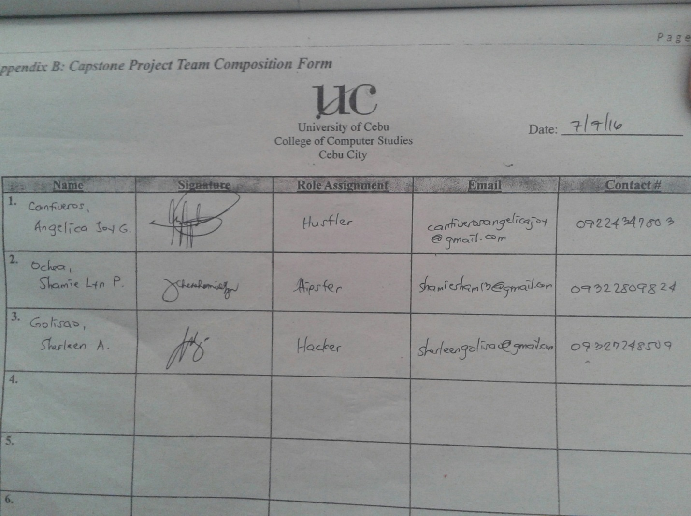

**APPENDIX E: Capstone Project Working Title Form**

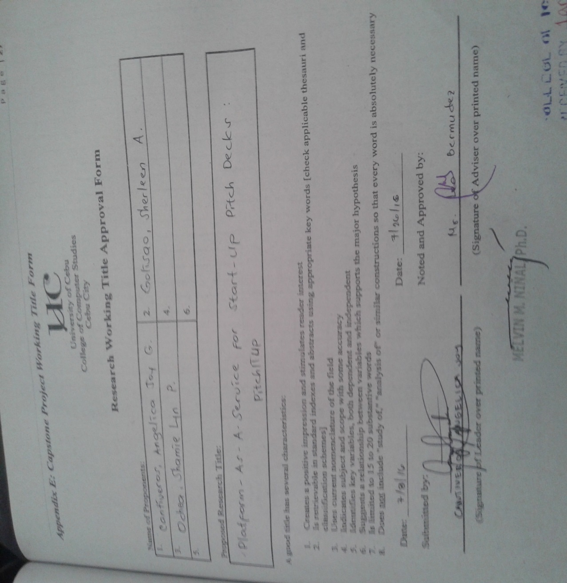

**APPENDIX G: Consultation Logs form**

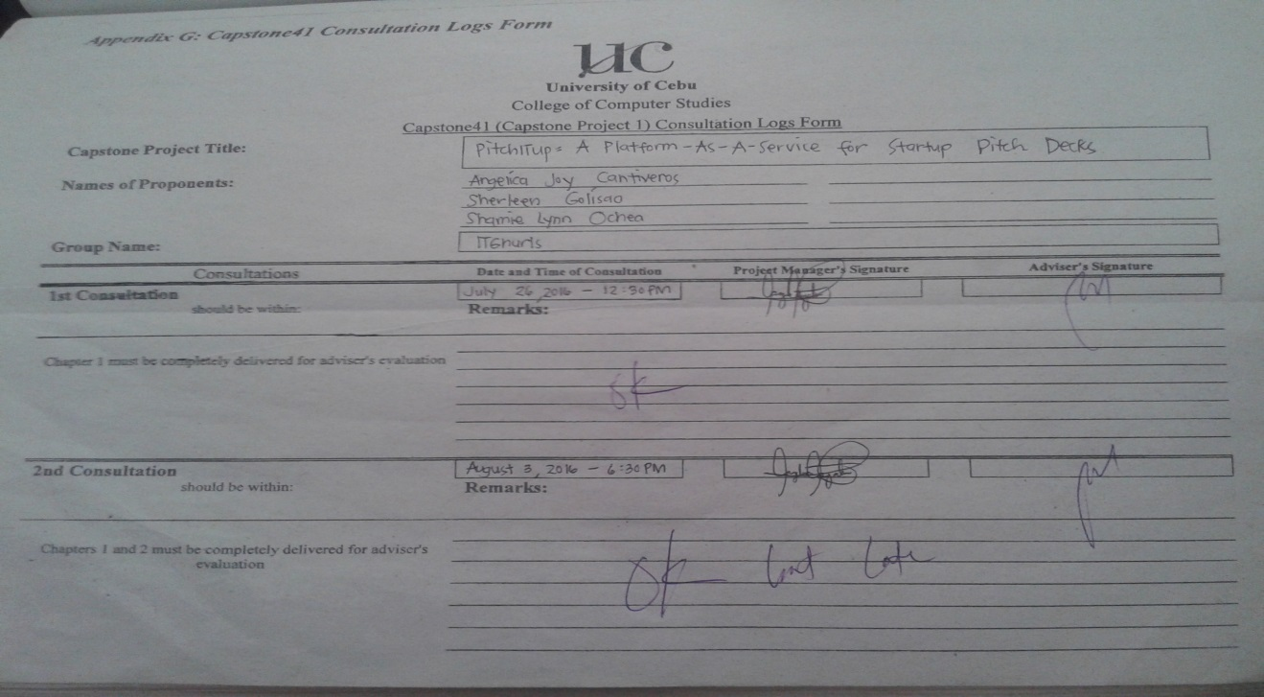

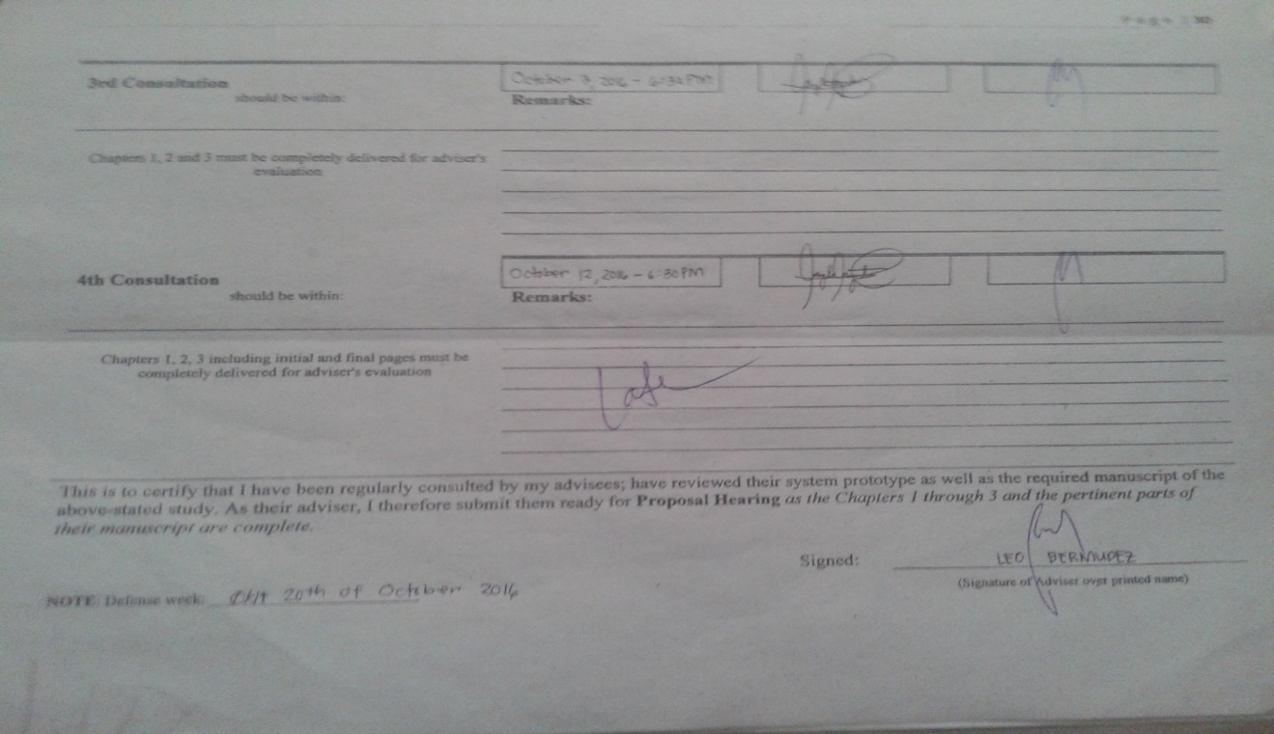

**APPENDIX H: Censor/Technical Editor’s Certificate Form**



## 

**APPENDIX L: Capstone Project Hearing Notice Form**

